Sample for Part 1 – Assignment 2 Normalization

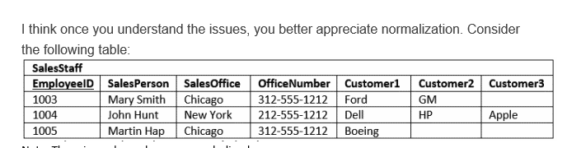

Five raw data elements

**UNF** – gathering and listing all raw data elements

Employee id, sales person, sales office location, office phone number, customer name, city, country

– **7 DATA ELEMENTS**

1NF --- remove repeating groups, identify primary key (candidate keys)

CUSTOMER – customer name

EMPLOYEE – employee id, employee name, sales office, sales office number, office city, office country

– **7 DATA ELEMENTS**

2NF --- all columns depend on primary key

CUSTOMER – customer name

EMPLOYEE – employee id, employee name

SALES OFFICE – sales office, sales office number, office city, office country

– **7 DATA ELEMENTS**

3NF --- no transitively dependencies

– **7 DATA ELEMENTS**

CUSTOMER – customer name

EMPLOYEE – employee id, employee name

SALES OFFICE – sales office, sales office number

CITY - city name

COUNTRY -- country name

**Refinements**

* Fix column names
* Make sure my primary key choices are numeric

CUSTOMER – CUSTOMER IDENTIFIER (SK), customer name

EMPLOYEE – employee number, employee name

SALES OFFICE – sales office identifier(SK), sales office location, sales office phone number

CITY - city identifier (SK), city name

COUNTRY -- country identifier (SK), country name

Last step for Part 1 create data model in PGMODELER

FINAL --- refinement stage

SALES OFFICE – sales office identifier (SK), sales office location, sales office telephone number

CITY – city identifier (SK), city name

COUNTRY – country identifier (SK), country name

CUSTOMER – customer identifier (SK), customer name

EMPLOYEE – employee identifier, employee name

Refinements

* Make PK numeric (integer/smallint/etc.)
* Clean up column names